|  |  |
| --- | --- |
| Date | 29 April 2023 |
| Team ID | NM2023TMID01052 |
| Project Name | Project- AI Enabled Car Parking using Open CV |
| Maximum Mark | 4 Marks |

**Brainstorm & Idea Prioritization Template:**

Brainstorming is the process of generating a large number of ideas and solutions to a problem or challenge. Prioritization, on the other hand, involves ranking and evaluating these ideas in order to determine which ones are the most promising or feasible.

Use this template in your own brainstorming sessions so your team can unleash the imagination and start shaping concepts even if you're not sitting in the same room.

**Step-1: Team Gathering, Collaboration and Select the Problem Statement**

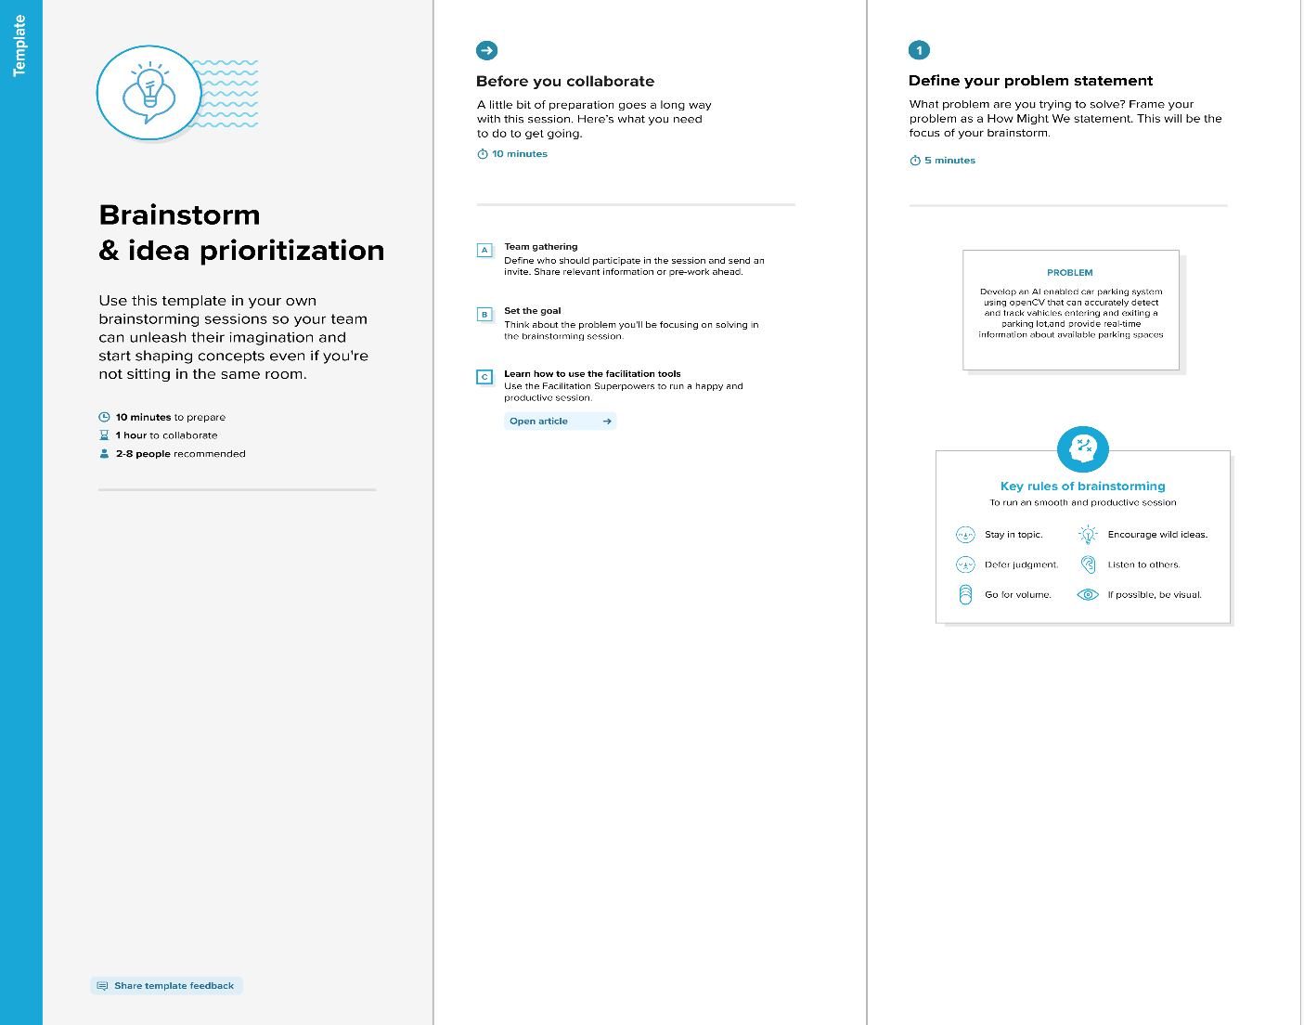

**Step-2: Brainstorm, Idea Listing and Grouping**

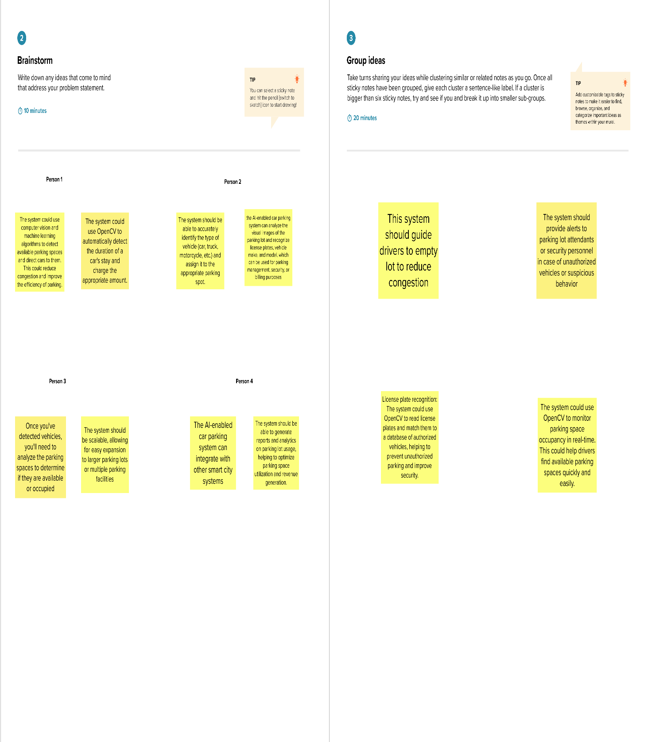

**Step-3: Idea Prioritization**

